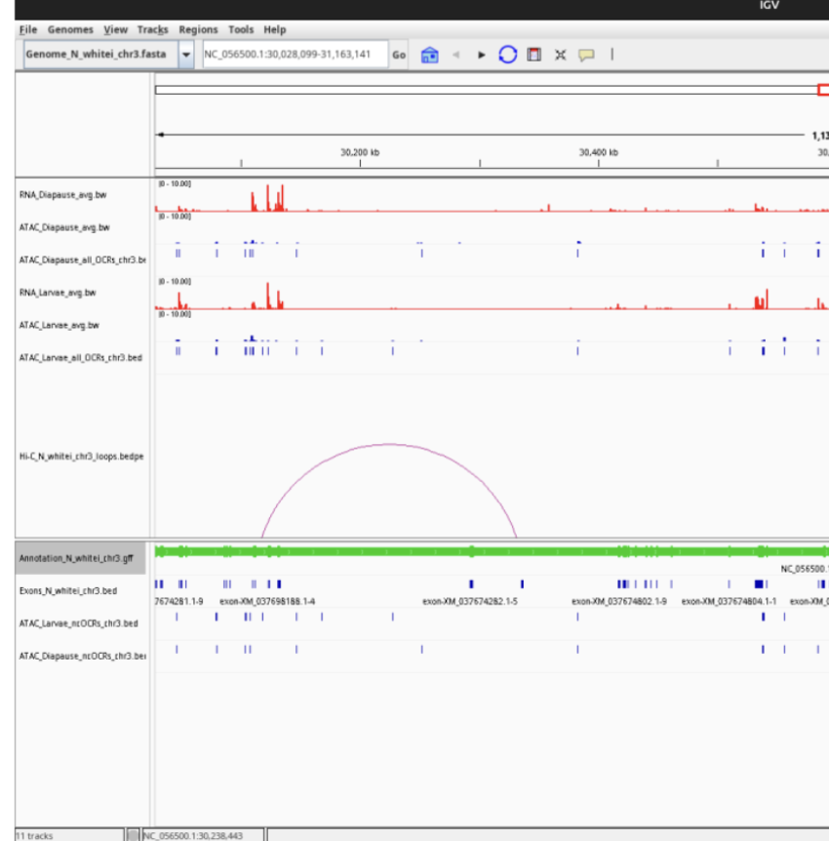

This figure highlights a regulatory region on chromosome 3 where several genomic datasets are combined to compare gene control between diapause and larval stages. The red RNA-seq tracks show which genes are being expressed, with taller peaks meaning stronger transcription. The blue ATAC-seq tracks mark open chromatin regions where DNA is more accessible. That means possible promoters, enhancers, or other regulatory sites involved in controlling nearby genes.
The non-coding OCR tracks focus on accessible regions outside exons, making them strong candidates for regulatory elements. The purple Hi-C loops reveal long-range DNA interactions where distant regions may contact gene promoters to influence activity. Lastly, the green annotation track shows gene and exon positions. Together, these layers suggest that changes in chromatin accessibility and genome looping help drive stage-specific gene expression on chromosome 3.

